INSTALLATION AND USER INSTRUCTIONS
Product Name
Product Model/Type
[INSERT PRODUCT IMAGE]

Month 20YY
Version X.XX

DISCLAIMER
Lorem ipsum dolor sit amet, consectetur adipiscing elit. Etiam at porta est, et lobortis sem. Duis imperdiet in nisl sed luctus. Vivamus hendrerit molestie urna, eu viverra velit porttitor sit amet. Donec nec ligula vitae elit venenatis tincidunt. Curabitur in est placerat, lobortis ante sit amet, tincidunt tortor. Duis ligula dui, tincidunt ut aliquam quis, gravida in libero. Nunc vel lacinia turpis. Etiam metus neque, ultricies eget odio eu, mollis ultricies lectus. Vestibulum consectetur turpis eget diam dignissim posuere.
Copyright © 20YY by [Company]
All rights reserved. No part of this publication may be reproduced, distributed, or transmitted in any form or by any means, including photocopying, recording, or other electronic or mechanical methods, without the prior written permission of the publisher. For permission requests, write to the publisher, addressed “Attention: Permissions Coordinator,” at the address below.
[Company] [Address]
[Phone] [Fax] [Website]

Table of Contents
1 PREFACE 7
1.1 Description of the user 7
1.2 Conventions used in this manual 7
1.3 Explanation of safety warnings 8
1.4 Retaining instructions 8
1.5 Obtaining documentation and information 9
1.5.1 Internet 9
1.5.2 Ordering documentation 9
1.5.3 Documentation feedback 9
2 Description of the product 10
2.1 Purpose of the product 10
2.2 Technical data 10
2.3 Product Compliance 10
2.5 Product elements 11
2.6 Understanding the user interface 12
2.7 Operating panels 13
3 Safety instructions 14
3.1 How to use the product safely 14
3.1.1 Safety information for vulnerable people 14
3.1.2 Personal safety 14
3.1.3 Work area safety 14
3.1.4 Electrical safety 14
3.2 Graphical symbols 15
3.2.1 Explanation of safety information on the packaging and product 15
3.2.2 Explanation of graphical symbols in the user manual 15
4 Preparation 16
4.1 How to transport and store the product 16
4.1.1 Lifting, handing and transporting the product 16
4.1.2 Storing the product 16
4.2 How to install the product 17
4.2.1 Removal of the transport and packaging restraints 17
4.2.2 Unpacking the product 17
4.2.3 Packaging contents 18
4.2.4 Conditions for assembling 19
4.2.5 Installation of the product 20
4.3 How to commission the product 21
5 Operation/Use 22
5.1 How to use the product 22
5.1.1 Operational environment 22
5.1.2 Manual operating techniques 22
5.1.3 Local/Remote operation 22
5.1.4 Manual/Automatic operation 22
5.1.5 Starting/Stopping the product’s operation 23
5.1.6 Checks before using the product 23
5.1.7 Using the product 24
5.2 Software documentation 25
5.2.1 Setting up the product 25
5.2.2 Adding products with the software 26
5.2.3 Software settings 27
5.3 What to do in emergency and exceptional situations 28
5.3.1 Emergency situation 28
5.3.2 Exceptional situations 28
6 Maintenance and cleaning 29
6.1 How to maintain the product 29
6.1.1 Product maintenance by non-skilled persons 29
6.1.2 Product maintenance by skilled persons 29
6.1.3 Planned maintenance 31
6.2 How to clean the product 31
7 Troubleshooting and repair 32
7.1 How to Identify and solve problems 32
7.1.1 Troubleshooting and repair by non-skilled persons 32
7.1.2 Troubleshooting and repair by skilled persons 32
7.2 How to Repair the Product 33
7.2.1 Repair by non-skilled persons 33
7.2.2 Repair by skilled persons 36
8 DISPOSAL 39
8.1 How to disassemble the Product 39
8.2 How to recycle parts 39
8.3 How to dispose the product 39
8.3.1 Disposal of electronic components 39
8.3.2 Disposal of packaging waste 39
8.3.3 Disposal of batteries 40
Appendix A. Supplied accessories, consumables and spare parts 41
Supplied accessories 41
Consumables 41
Spare/replacement parts 41
Appendix B. Related documentation 42
Glossary 43
Index 44

PREFACE

Description of the user
[Provide a description of the user for which the user manual is intended. Describe the user type, for example if the intended user needs to be a skilled person and if there are more than one users (e.g. installer and operator or end-user)
Also provide information regarding restrictions on the users who are permitted to use the product together with any skills, training, certification or expertise required]

Conventions used in this manual
The following style conventions are used in this document:
Bold
Names of product elements, commands, options, programs, processes, services, and utilities Names of interface elements (such windows, dialog boxes, buttons, fields, and menus)
Interface elements the user selects, clicks, presses, or types
Italic
Publication titles referenced in text
Emphasis (for example a new term)
Variables
Courier
System output, such as an error message or script
URLs, complete paths, filenames, prompts, and syntax
User input variables
< > Angle brackets surround user-supplied values
[ ] Square brackets surround optional items
| Vertical bar indicates alternate selections - the bar means “or”

Explanation of safety warnings
DANGER! Danger indicates a hazard with a high level of risk which, if not avoided, will result in death or serious injury
WARNING! Warning indicates a hazard with a medium level of risk which, if not avoided, could result in death or serious injury.
CAUTION! Caution indicates a hazard with a low level of risk which, if not avoided, could result in minor or moderate injury.
NOTICE Indicates information considered important, but not hazard-related.

Retaining instructions
Read and understand this manual and its safety instructions before using this product. Failure to do so can result in serious injury or death.

Follow all the instructions. This will avoid fire, explosions, electric shocks or other hazards that may result in damage to property and/or severe or fatal injuries.

Keep all safety information and instructions for future reference and pass them on to subsequent users of the product.

Obtaining documentation and information

Internet
The latest version of the documentation is available at the following address: http://www.yourwebsite.com
Do you want to know how you can save on printing costs and reduce the environmental impact of your manuals? We can create your product information for both print and online. We know exactly what information needs to be provided printed and what can be placed online from a legal standpoint. Would you like to discuss the possibilities for HTML, video, AR or interactive user manuals? Ask us for the possibilities at info@instrktiv.com
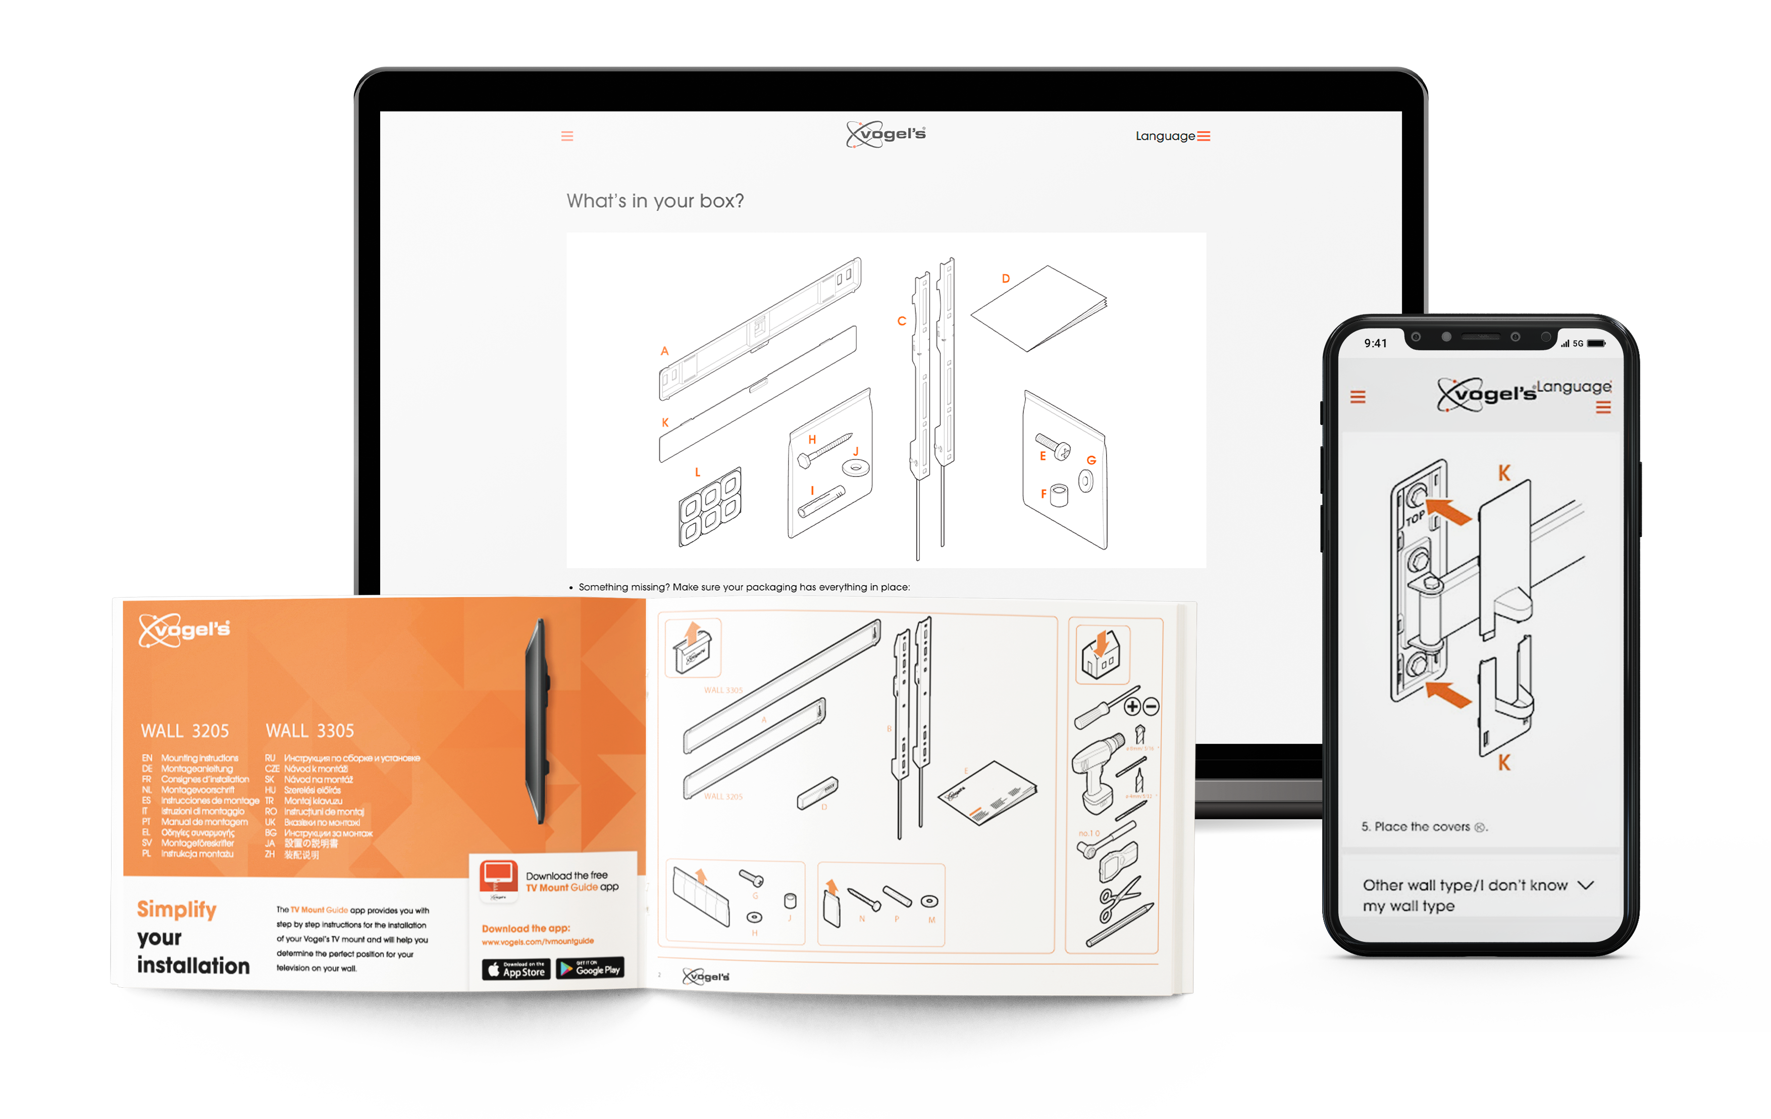

Ordering documentation
Documentation, user instructions and technical information can be ordered by calling [Company] at [telephone number].

Documentation feedback
If you are reading [Company] product documentation on the internet, any comments can be submitted on the support website. Comments can also be sent to [email address].
We appreciate your comments.

Description of the product

Purpose of the product
[Introduce the product and its purpose, mentioning key features and accessories]
Lorem ipsum dolor sit amet, consectetur adipiscing elit. Etiam at porta est, et lobortis sem. Duis imperdiet in nisl sed luctus. Vivamus hendrerit molestie urna, eu viverra velit porttitor sit amet. Donec nec ligula vitae elit venenatis tincidunt. Curabitur in est placerat, lobortis ante sit amet, tincidunt tortor. Duis ligula dui, tincidunt ut aliquam quis, gravida in libero. Nunc vel lacinia turpis. Etiam metus neque, ultricies eget odio eu, mollis ultricies lectus. Vestibulum consectetur turpis eget diam dignissim posuere.

Technical data
Parameter | Unit
Power | x W
Voltage | x V
Weight | x.xx kg (x.xx lbs)
Software version | 2.21
Operating temperature | x to x °C ( x to x °F)
Humidity range | x to x % relative humidity (RH)
…
Table 1 Use tables for text that is difficult to understand in paragraph form (rule 72.1 of the INSTRKTIV User Manual Design Guide)

Product Compliance
[List any regulations, directives and/or standards to which the product complies]
This product complies to:
- Product standard A
- Product standard B

Product elements
[Product image with callouts at main elements
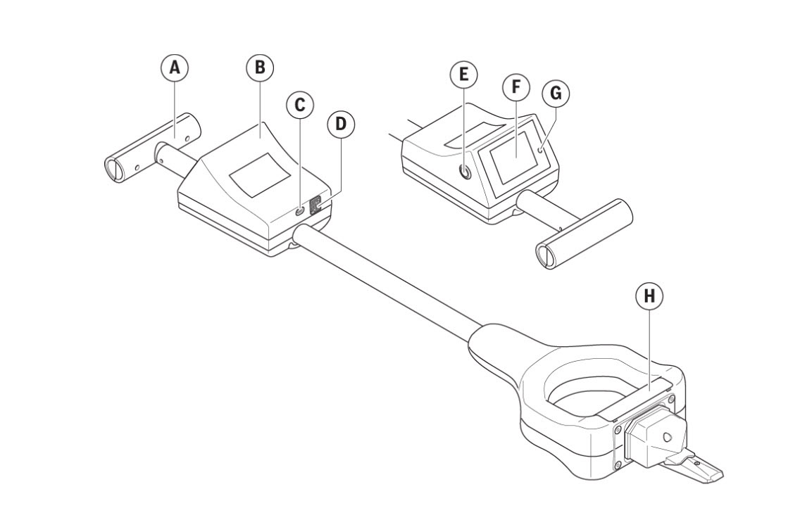
Fig. 1 The use of captions is optional (rule 8.1 of the INSTRKTIV User Manual Design Guide)
- Element A
- Element B
- Element C
- …

Understanding the user interface
[Provide an explanation of the user interface, if applicable]
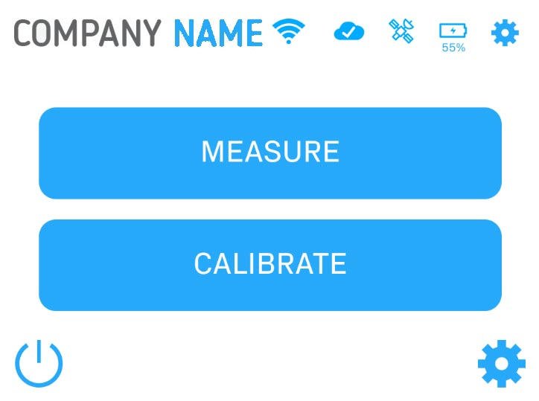
Fig. 2 This is a caption
Nr. | Name | Function
1 | WiFi connection | Indicates if the device is connected to a WiFi network  - best WiFi signal strength  - bad WiFi signal strength  - no WiFi connection
2 | Cloud connection
 | … | …
Table 2 This is a table

Operating panels
[Provide an explanation of all operating panels, if applicable]
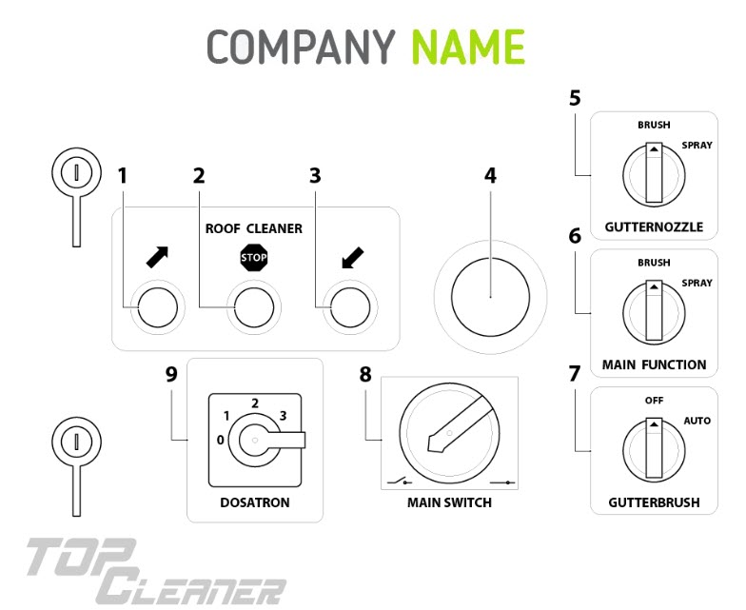
Fig. 3 This is a caption

Safety instructions
[The grouped safety messages typically contain only those safety messages that apply to the entire product life cycle of the product]
WARNING! A good warning consists of three parts: The type and source of hazard, the consequences in the event of non-compliance and the measures to avoid the hazard. For example: WARNING! Hazardous voltage inside. Can shock, burn or cause death. Keep out.

How to use the product safely

Safety information for vulnerable people
- Lorem ipsum dolor sit amet
- Donec nec ligula vitae

Personal safety
- Lorem ipsum dolor sit amet
- Donec nec ligula vitae

Work area safety
- Lorem ipsum dolor sit amet
- Donec nec ligula vitae

Electrical safety
- Lorem ipsum dolor sit amet
- Donec nec ligula vitae

Graphical symbols

Explanation of safety information on the packaging and product
Symbol | Meaning
 | Read and understand the manual and its safety instructions before using this product.
Table 3 This is a table

Explanation of graphical symbols in the user manual
Symbol | Meaning
Table 4 This is a table

Preparation

How to transport and store the product

Lifting, handing and transporting the product
[Provide lifting, handling and transporting information, if applicable]
To lift the product safely:
- Number steps using 1, 2, 3 (rule 53.3 of the INSTRKTIV User Manual Design Guide)
- Use short sentences with one instruction in each sentence (rule 53.4 of the INSTRKTIV User Manual Design Guide).
- Begin instructions with a strong and active verb in the imperative (command) form (rule 53.5 of the INSTRKTIV User Manual Design Guide).
To handle the product safely:
- Do this.
- Complete an action.
- Do that.
To transport the product safely:
- Do this.
- Complete an action.
- Do that.

Storing the product
[Provide storage information, if applicable]
Lorem ipsum dolor sit amet, consectetur adipiscing elit. Etiam at porta est, et lobortis sem. Duis imperdiet in nisl sed luctus.
To store the product safely:
- Do this.
- Complete an action.
- Do that.

How to install the product

Removal of the transport and packaging restraints
Lorem ipsum dolor sit amet, consectetur adipiscing elit. Etiam at porta est, et lobortis sem. Duis imperdiet in nisl sed luctus.
Lorem ipsum:
- Do this.
- Complete an action.
- Do that.

Unpacking the product
Lorem ipsum dolor sit amet, consectetur adipiscing elit. Etiam at porta est, et lobortis sem. Duis imperdiet in nisl sed luctus.
Lorem ipsum:
- Do this.
- Complete an action.
- Do that.

Packaging contents
Lorem ipsum dolor sit amet, consectetur adipiscing elit. Etiam at porta est, et lobortis sem. Duis imperdiet in nisl sed luctus.
Lorem ipsum:
- Part A
- Part B
- Part C

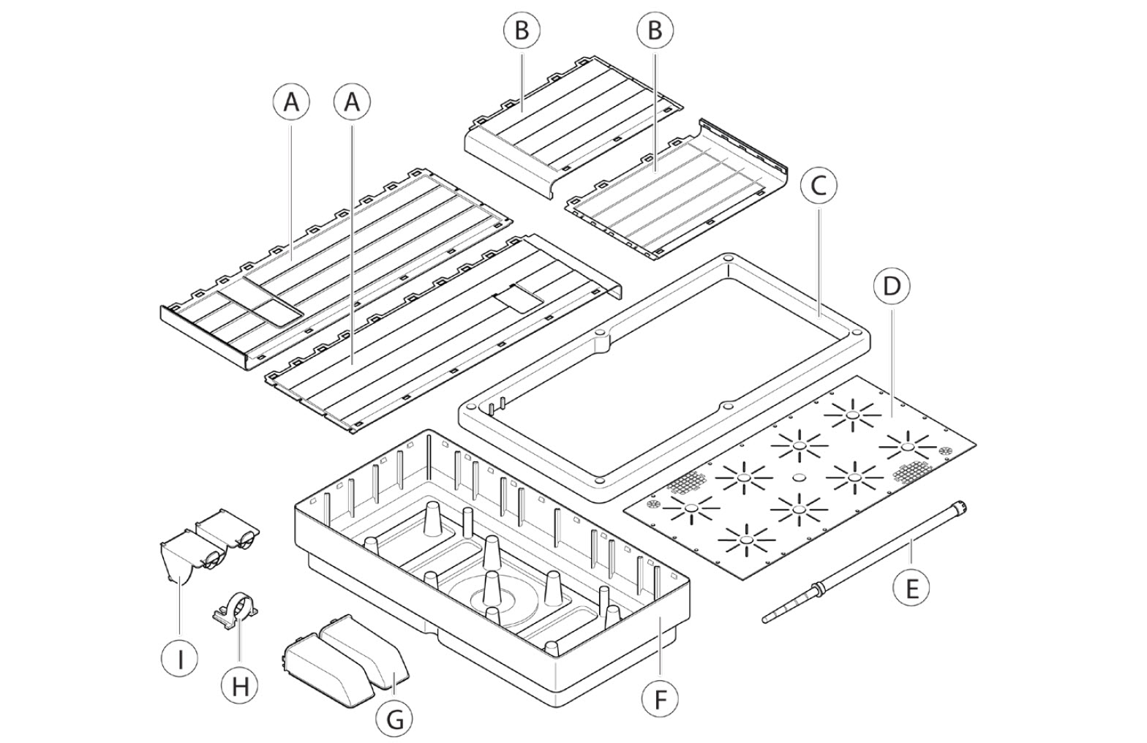
Fig. 4 This is a caption

Conditions for assembling
Lorem ipsum dolor sit amet, consectetur adipiscing elit. Etiam at porta est, et lobortis sem. Duis imperdiet in nisl sed luctus.
Lorem ipsum:
- Condition 1
- Condition 2
- Condition 3

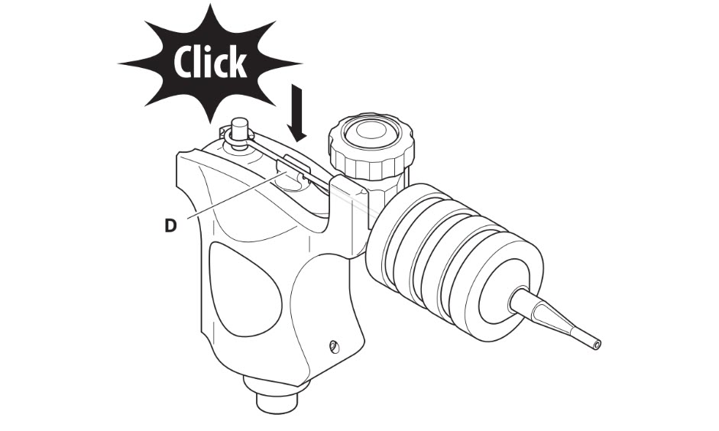
Fig. 5 This is a caption

Installation of the product
To install the product:
- Do this.
- Complete an action.
- Do that.

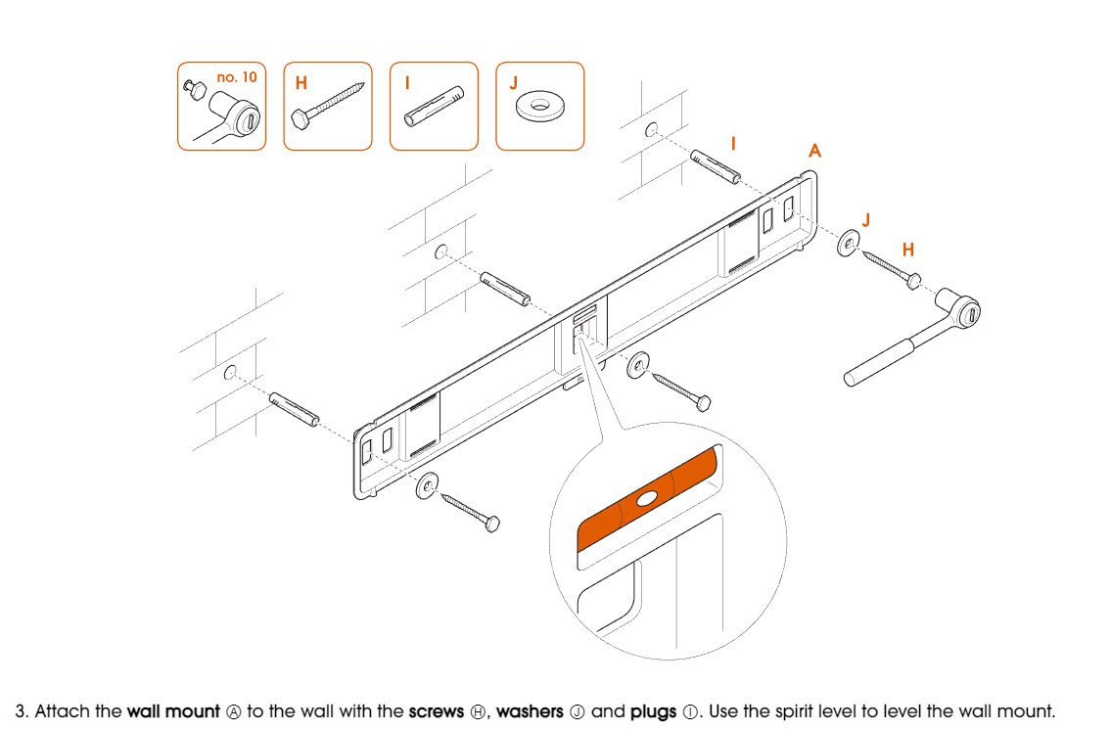
Fig. 6 This is a caption

How to commission the product

Lorem ipsum dolor sit amet, consectetur adipiscing elit. Etiam at porta est, et lobortis sem. Duis imperdiet in nisl sed luctus.
Lorem ipsum:
- Do this.
- Complete an action.
- Push the button.

Operation/Use

How to use the product

Operational environment
Lorem ipsum dolor sit amet, consectetur adipiscing elit. Etiam at porta est, et lobortis sem. Duis imperdiet in nisl sed luctus.

Manual operating techniques
Lorem ipsum dolor sit amet, consectetur adipiscing elit. Etiam at porta est, et lobortis sem. Duis imperdiet in nisl sed luctus.
Lorem ipsum:
- Do this.
- Complete an action.
- Push the button.

Local/Remote operation
Lorem ipsum dolor sit amet, consectetur adipiscing elit. Etiam at porta est, et lobortis sem. Duis imperdiet in nisl sed luctus.
Lorem ipsum:
- Do this.
- Complete an action.
- Push the button.

Manual/Automatic operation
Lorem ipsum dolor sit amet, consectetur adipiscing elit. Etiam at porta est, et lobortis sem. Duis imperdiet in nisl sed luctus.
Lorem ipsum:
- Do this.
- Complete an action.
- Push the button.

Starting/Stopping the product’s operation
Lorem ipsum dolor sit amet, consectetur adipiscing elit. Etiam at porta est, et lobortis sem. Duis imperdiet in nisl sed luctus.
Lorem ipsum:
- Do this.
- Complete an action.
- Push the button.

Checks before using the product
Lorem ipsum dolor sit amet, consectetur adipiscing elit. Etiam at porta est, et lobortis sem. Duis imperdiet in nisl sed luctus.
Lorem ipsum:
- Do this.
- Complete an action.
- Push the button.

Using the product
Lorem ipsum:
- Do this.
- Complete an action.
- Push the button.
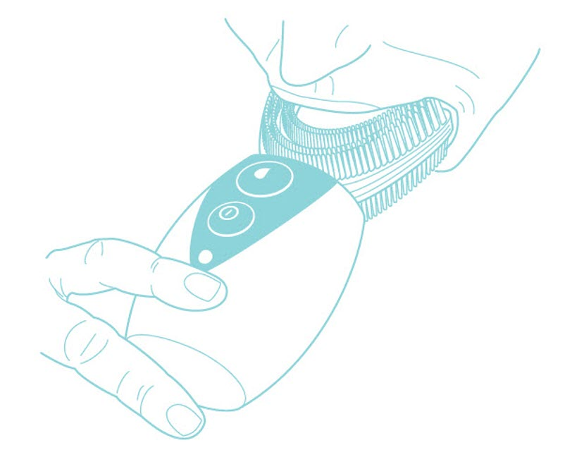 Fig. 7 This is a caption

Software documentation

Setting up the product
To set up the product with the software:
- Click [button].
The [name] dialog box opens.
- When prompted to close [software name], click Yes.
The [name window] window opens.
- Click [button].
All [product name] detected by [software] appear within the window.
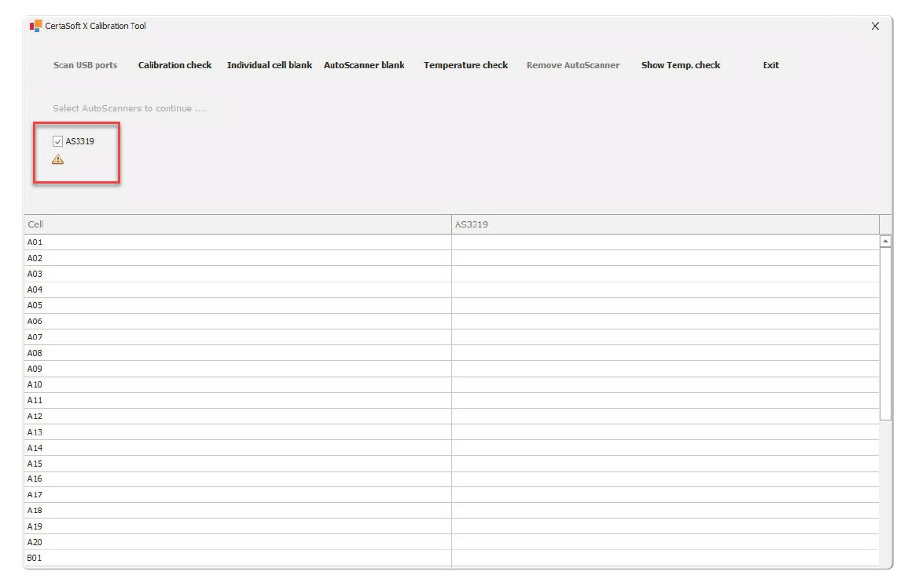
Fig. 8 This is a caption

Adding products with the software
To add products with the software:
- Click the Add button.
Click the [button name] button.
The [name] overview opens.
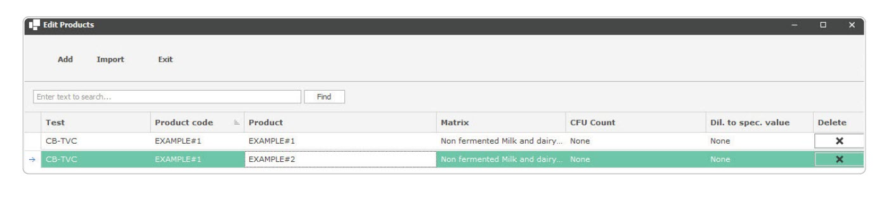
Fig. 9 This is a caption

- Click [name button].
The [name window] window opens.
- Click Import.
The Select Import File dialog box opens.
- Locate and select the batch file.
- Click Open.

Software settings
To adjust the temperature of module A Ⓐ and module B Ⓑ:

- Click Temp settings.
The [name] dialog box opens.
- In the [name section] section, select the device you would like to set the temperature for.
- Click Save.

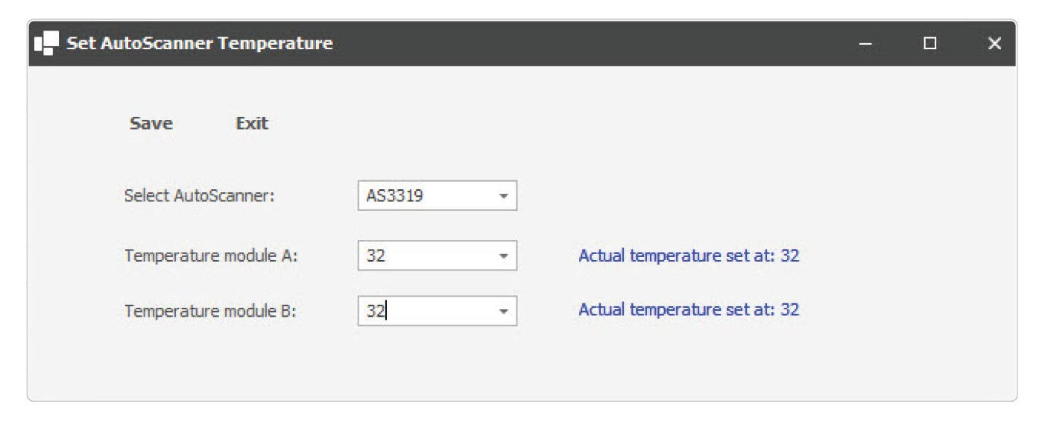
Fig. 10 This is a caption
To generate a calibration curve:

- Click on the [name/image] icon at the top right corner of the screen.
The Settings menu appears.
- Click on the [name/image] icon.
The [name window] window opens.
- Click Save.
- The [setting] is now visible in [software].

What to do in emergency and exceptional situations

Emergency situation
In case of an emergency situation:
- Do this.
- Complete an action.
- Do that.

Exceptional situations
In case of an exceptional situation:
- Do this.
- Complete an action.
- Do that.

Maintenance and cleaning
NOTICE: Lorem ipsum dolor sit amet, consectetur adipiscing elit. Etiam at porta est, et lobortis sem. Duis imperdiet in nisl sed luctus.

How to maintain the product

Product maintenance by non-skilled persons

Replacing the [part] (e.g. battery)
To replace the [part]:
- Do this.
- Complete an action.
- Do that.

Replacing the [part] (e.g. light):
To replace the [part]:
- Do this.
- Complete an action.
- Do that.

Product maintenance by skilled persons

Lubricating the product
To lubricate the product:
- Do this.
- Complete an action.
- Do that.

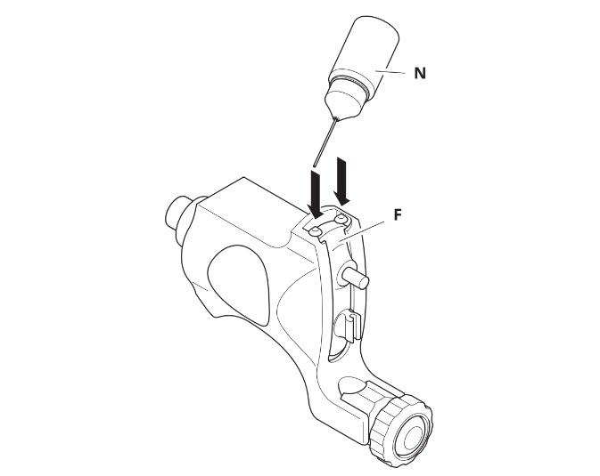
Fig. 11 This is a caption

Planned maintenance
Maintenance tasks shall be done according to the following plan:
Task | Frequency
Replacing the battery | Every 6 months
Replacing the light | Every 12 months
Lubricating the bearings | Every week
Table 5 This is a table

How to clean the product
To clean the product:
- Do this.
- Complete an action.
- Do that.
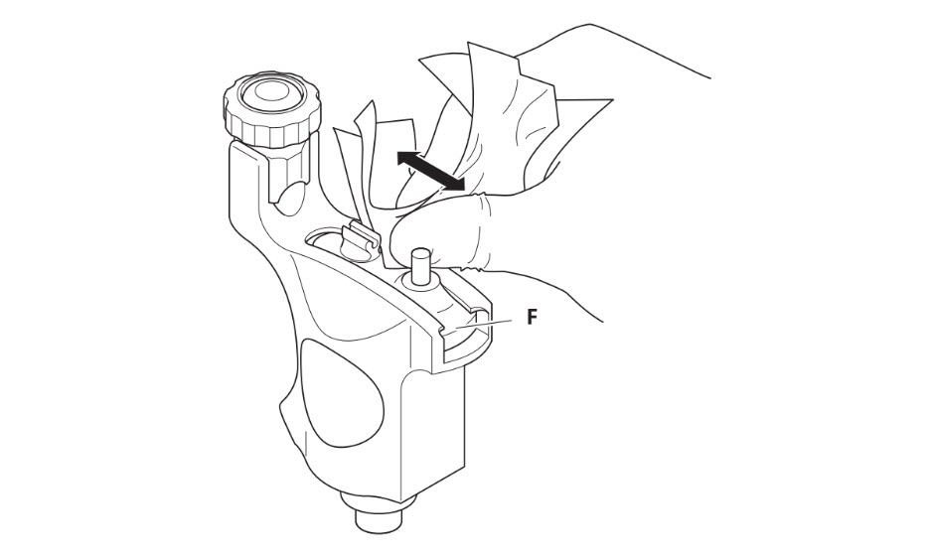
Fig. 12 This is a caption

Troubleshooting and repair

How to Identify and solve problems

Troubleshooting and repair by non-skilled persons
WARNING: Lorem ipsum dolor sit amet, consectetur adipiscing elit. Etiam at porta est, et lobortis sem. Duis imperdiet in nisl sed luctus.
Error | Cause | Solution
Product does not start | Part A is broken | Replace part A. See 7.2.1.4 Replacement of Part A
… | … | …
Table 6 This is a table

Troubleshooting and repair by skilled persons
WARNING: Lorem ipsum dolor sit amet, consectetur adipiscing elit. Etiam at porta est, et lobortis sem. Duis imperdiet in nisl sed luctus.
Error | Cause | Solution
Table 7 This is a table

How to Repair the Product

Repair by non-skilled persons
WARNING: Lorem ipsum dolor sit amet, consectetur adipiscing elit. Etiam at porta est, et lobortis sem. Duis imperdiet in nisl sed luctus.

Specials tools
The following tools are needed for reparation tasks:
Task | Tools
Task 1 | Tool 1  Tool 2  Tool 3
Task 2 | Tool 1  Tool 2
Table 8 This is a table

Equipment
The following equipment is needed for reparation tasks:
Task | Tools
Task 1 | Equipment 1  Equipment 2  Equipment 3
Task 2 | Equipment 1  Equipment 2
Table 9 This is a table

Materials
The following materials are needed for reparation tasks:
Task | Tools
Task 1 | Material 1  Material 2  Material 3
Task 2 | Material 1  Material 2
Table 10 This is a table

Replacement of part A
To replace part A:
- Do this.
- Complete an action.
- Do that.

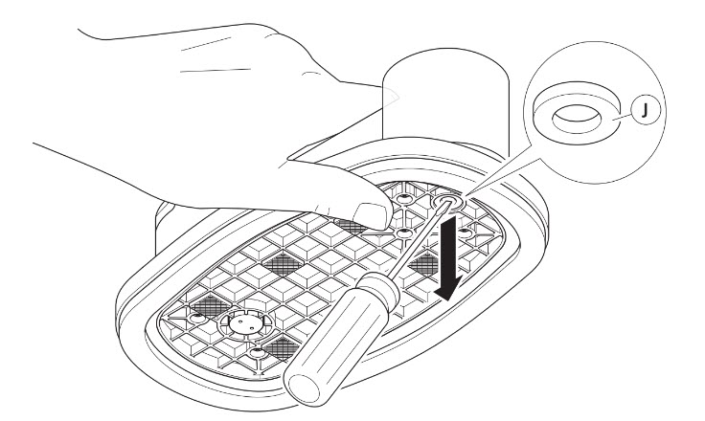
Fig. 13 This is a caption

Replacement of part B
To replace part B:
- Do this.
- Complete an action.
- Do that.
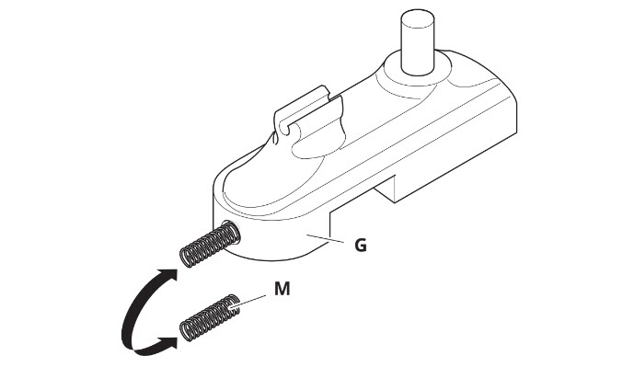
Fig. 14 This is a caption

Repair by skilled persons
WARNING: Lorem ipsum dolor sit amet, consectetur adipiscing elit. Etiam at porta est, et lobortis sem. Duis imperdiet in nisl sed luctus.

Replacement of part C
The following tools are needed for reparation tasks:
Task | Tools
Task 1 | Tool 1  Tool 2  Tool 3
Task 2 | Tool 1  Tool 2
Table 11 This is a table

Equipment
The following equipment is needed for reparation tasks:
Task | Tools
Task 1 | Equipment 1  Equipment 2  Equipment 3
Task 2 | Equipment 1  Equipment 2
Table 12 This is a table

Materials
The following materials are needed for reparation tasks:
Task | Tools
Task 1 | Material 1  Material 2  Material 3
Task 2 | Material 1  Material 2
Table 13 This is a table

Replacement of part C
To replace part C:
- Do this.
- Complete an action.
- Do that.

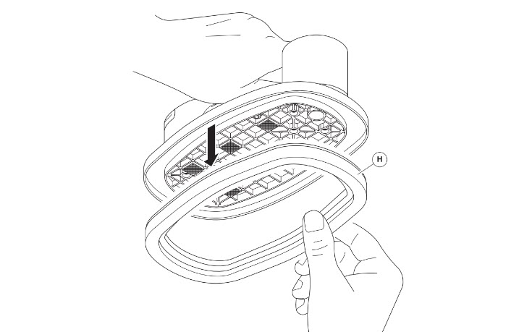
Fig. 15 This is a caption

Replacement of part D
To replace part D:
- Do this.
- Complete an action.
- Do that.
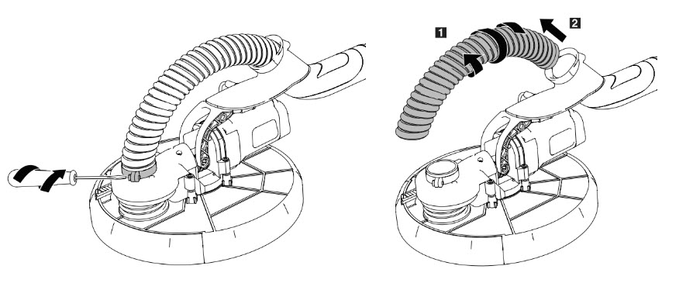
Fig. 16 This is a caption

DISPOSAL

How to disassemble the Product
To disassemble the product:
- Do this.
- Complete an action.
- Do that.

How to recycle parts
To recycle part A:
- Do this.
- Complete an action.
- Do that.

How to dispose the product
To dispose the product:
- Do this.
- Complete an action.
- Do that.

Disposal of electronic components
To dispose electronic components:
- Do this.
- Complete an action.
- Do that.

Disposal of packaging waste
To dispose packaging waste:
- Do this.
- Complete an action.
- Do that.

Disposal of batteries
To dispose batteries
- Do this.
- Complete an action.
- Do that.

Appendix A. Supplied accessories, consumables and spare parts

Supplied accessories
Image | Name | Article Number

Consumables
Image | Name | Article Number

Spare/replacement parts
Image | Name | Article Number

Appendix B. Related documentation
# | Document Title | Version # | Location | Author

Glossary
[Explain the meaning of all terms used in this document]
Term | Meaning

Index
A
Aftereight 532
Appendum
Appelsap 223

B
Borneo 321
Bravo 134
Bohemian 23-24

